## Logo Vectorizing in Flash Steps

We’re going to recreate your hand drawn company logo into a vector format. You will then be able to scale it up to any size, animate it, and publish it for the Internet. Your goal is to replicate your drawing, add color, and animate it. First you need to copy or crop and save it in Photoshop to prepare it for Flash.If it’s not available, re-draw it, scan it, and proceed.

**Open Photoshop and your hand drawn logo image.**

If you want to change the contrast or brightness go to IMAGE, ADJUSTMENTS, and LEVELS.

**Select only the area you want to vectorize in Flash with the marquee tool.**

Go to EDIT, COPY or Save it as a .JPG to your portfolio.

1. Open Flash. Import or paste your logo onto Flash’s stage.
2. Drag your image unto layer 1. If you want to change the transparency of the logo to see through it, right click on it and convert it into a symbol (Movie clip). Select symbol and go to the PROPERTIES panel, COLOR EFFECTS, and decrease the ALPHA setting.
3. Create a new layer on top of your hand drawn logo so it’s unaffected by your new work.

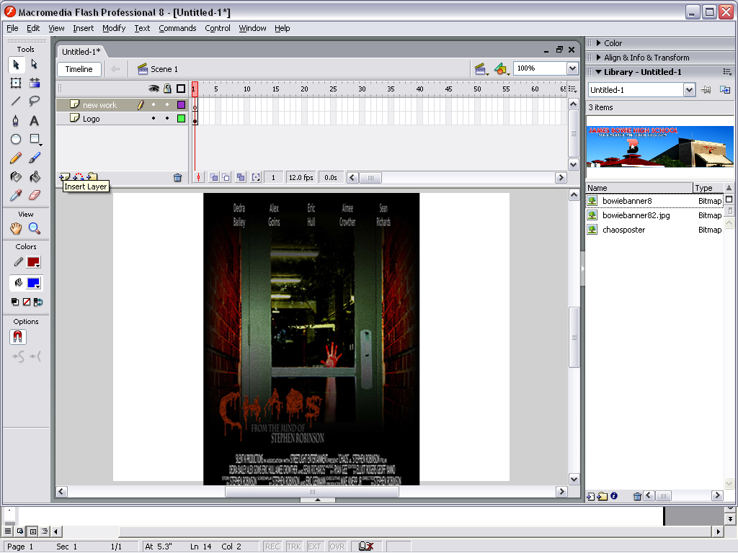

1. Lock the first layer.

**Don’t forget to prepare it for animating by putting animated parts on their own layers.**

Also you can watch the 1st 5 minutes of video tutorial “Logo animation.mov”

located in the Z:”Tutorials, Flash” folder if you need.

1. Trace over logo with the pen or line tool. Use the selection (V) tool to arch lines if you used the line tool. Use the sub-selection tool to adjust curves if you use the pen tool.
2. Turn on snapping by going to VIEW, SNAPPING, SNAP TO OBJECTS so the lines will connect easily and perfectly.

**Hints:**

* You can only arch quarter circle curves with the selection tool (V)
* Change thicknesses of lines by going to the PROPERTIES palette and the stroke settings
* You can turn on the anchors and move them with the subselection (A) tool.
* turn on the handles of the anchors to change curves by using the (C) tool.

Add color to it next!

# Create a logo with the Pen tool

The Pen tool offers a way to draw precise straight or curved line segments. Click to create points on straight line segments, and drag to create points on curved line segments. You can adjust the segments by adjusting points on the line. You'll use the Line and Pen tool to create the logo.

1. In the Tools panel, select the Pen tool pen or the Line tool.
2. Click the dot next to the number 1, and then click the dot next to the number 2 to create a straight line segment.

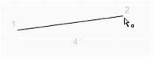

1. Click the dot next to the number 3 and next to the number 4 in sequence (as though you were completing a dot-to-dot drawing). You create the straight line segments that comprise the logo.
2. To close the path, position the Pen tool over the first anchor point (the dot by number 1). A small circle appears next to the pen tip when it is positioned correctly. Click to close the path. After the path is closed, it fills with the selected fill color.

By default, selected curve points appear as hollow circles, and selected corner points appear as hollow squares.

1. With the Selection tool, move the pointer around the logo that you created.

When you move the pointer over a corner point, which you can drag to create various angles, the pointer appears as follows:

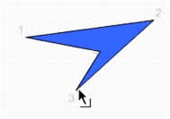When you move the pointer over a curved line segment (you don't have curve points in your logo), which you can drag to create various curved lines, the pointer appears as follows: 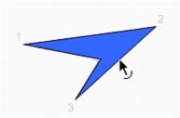

Get creative and make yourself proud. You will be able to put your logo on any website and print it large as a poster if you want.