Animated Signatures
For this two day assignment you will make an animated signature that you can embed in your future emails as a .gif file. You should use the tablet and stylus to create your signature in Flash. You will then make two different versions of it animating. One animation will be keyframed while the other will be a shape tweened mask. To read about masks go to pages 221-222 in your Flash HELP e-book .pdf.
- Open Flash and create a new document
- Connect the tablet with the usb cord.
- Turn on the pressure sensitive button below your brush size tool here 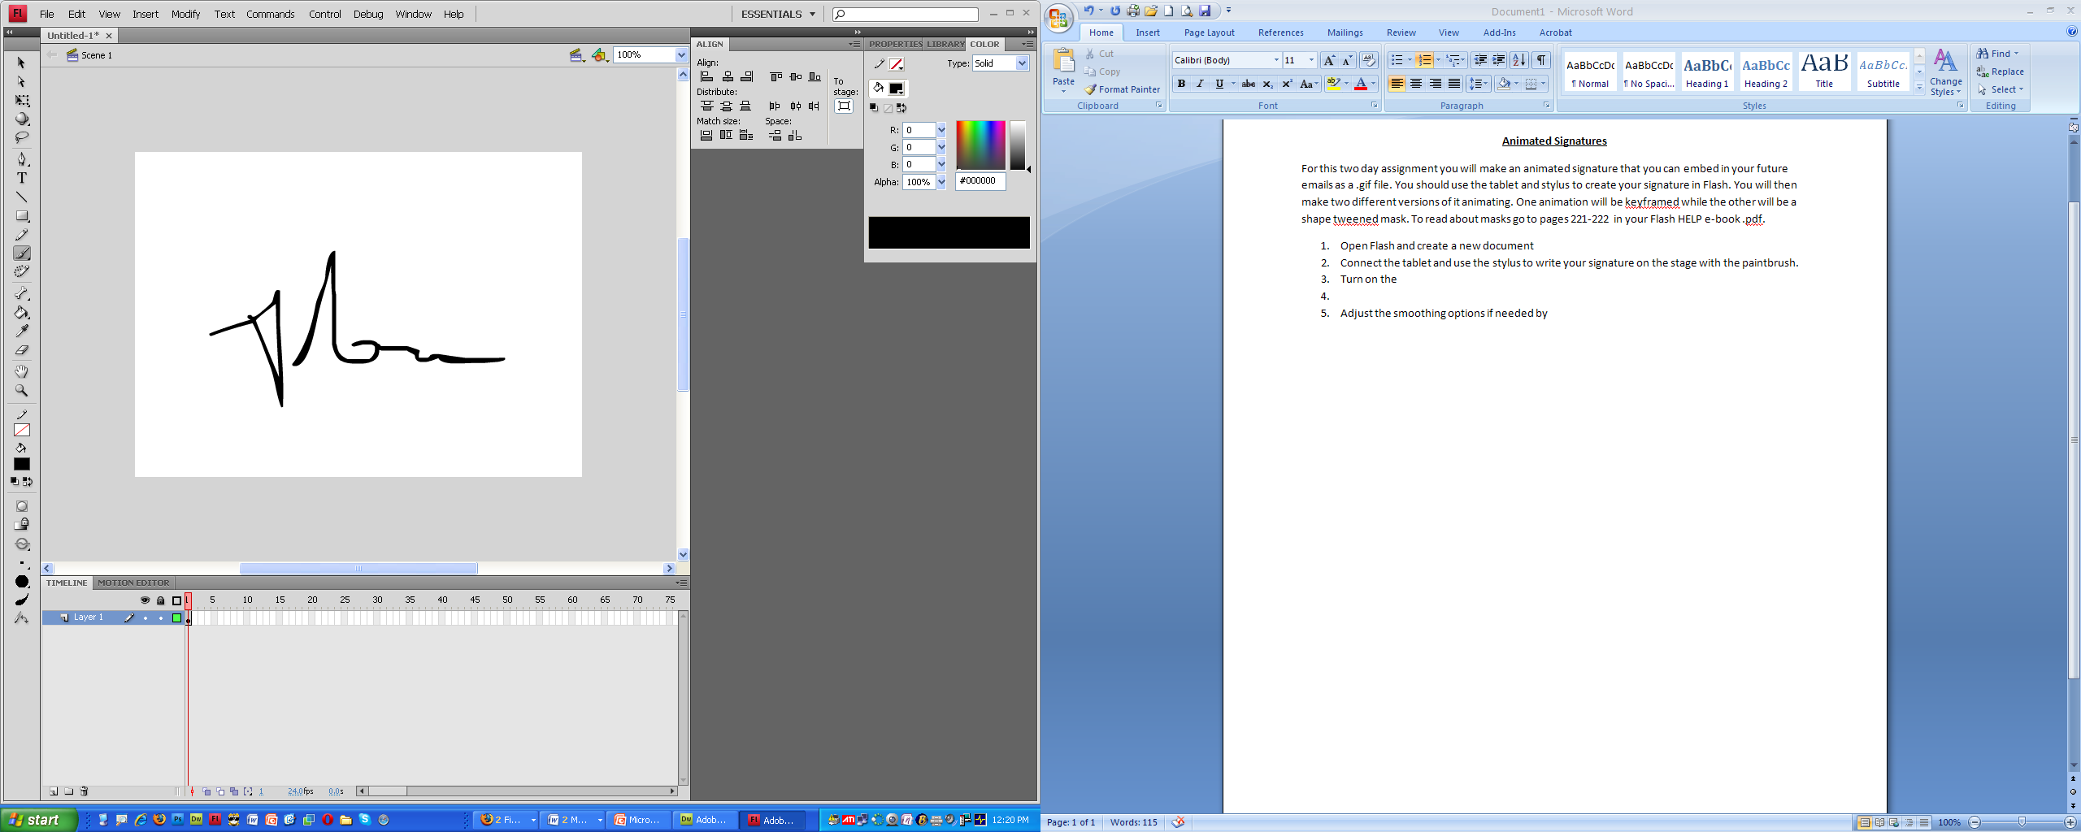
- Adjust the smoothing options if needed by going to MODIFY, SHAPE, ADVANCED SMOOTH. 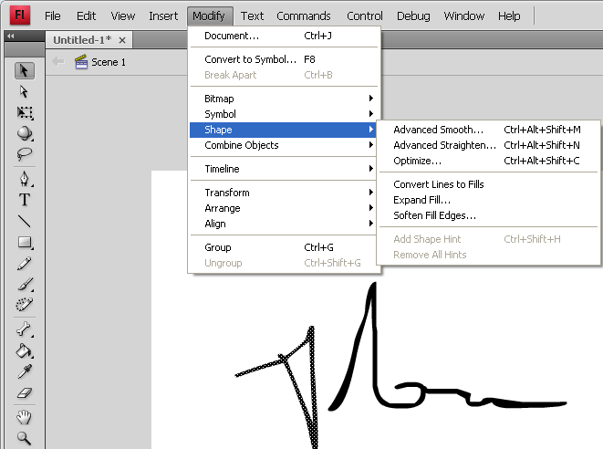
- Use the stylus to write your signature on the stage with the paintbrush.
- Use the Smooth tool (under the magnet) to smooth more if needed.
- If you don’t like it UNDO it (Ctrl & Z) and redo it.
- Once you finish your signature, select it by dragging a box around it with the selection tool and convert it to a graphic symbol to keep it safe in your library in case you need it again later.
- Save it to your “In Progress” folder.
- Click on your signature and break it apart (Ctrl & B) to make it raw again.

It’s time to create the keyframed animation. You’ll want it to be less than 50 frames all together.
- Press F6 to create a new keyframe
- Select the eraser tool and erase a little bit of the end of your signature. The less you delete the smoother it will animate but the slower it will go.
- Press F6 again to create another keyframe
- Erase more of your name in reverse.
- Press F6.
- Repeat the process until the name is completely erased. You should create one blank keyframe at the end.
- Now click on the layer to select the whole timeline of keyframes.
- Right click on the keyframes and choose REVERSE FRAMES.
- Now it’s time to reduce the document size. Go to MODIFY, DOCUMENT, & click CONTENTS. That will shrink the document size to fit around your signature perfectly.
- Next, it’s time to publish it as a .gif. Go to PUBLISH SETTINGS and select .gif. Click on the .GIF tab and make sure you check the ANIMATED feature. Now publish the .gif to the Z:Signture folder.
- Publish it to your “Finished Projects” folder too.

Now it’s time to create it again using a different technique with a shape tween mask.
To read about masks go to pages 221-222 in your Flash HELP e-book .pdf.

- Open the signature file you saved in your “In Progress” folder or remove all keyframes except for one and drag the signature symbol onto the stage.
- Create a new layer. Drag it up so it’s on top of the signature layer.
- Right click on it and select MASK. Your content will disappear.
- Unlock the mask layer. Only when the mask layer is locked do you see what it will look like when it’s a published file.
- Draw a thin rectangle to the left of your signature without a stroke using any color.
- On frame 40 (or the length you prefer your animation to be) select frames of both layers. Right click and create keyframes for them both.
- Click on the last keyframe of your mask layer and then select the rectangle.
- Change the shape of the rectangle to fit over your whole signature using the selection tool to alter it.
- Right click anywhere in between your two keyframes on the mask layer and create the shape tween.
- Lock the MASK layer to view it.
- Scrub the play head to see if it works or press ENTER. Your signature should appear from left to right. If you want it to animate it slower simply extend the shape tween length by adding more blank frames in between using F5 or drag the last keyframe to the right.
Remember you can adjust the shape tween to get various styles if you want.
- After finalizing the animated mask you need to publish it as a .gif again.
- Save the .fla and the .gif to Z:Signature folder. This time the .gif should be titled,”last name, mask-signature.gif”

You should have 3 files in the Z:Signature folder.
- The keyframed .gif
- The .fla file
- The masked shape tween .gif

